
STUDENT NAME: BRENDAN SHELTON ONYANGO
ADMISSION NUMBER: BSCCS/2024/55872
COURSE: BACHELORS IN COMPUTER SCIENCE
UNIT NAME: ETHICAL HACKING
UNIT CODE: BIT 4139
LECTURER NAME: MICHAEL NYORO
SEMESTER: YEAR 3 SEM 2

TABLE OF CONTENTS
Section | Title
Cover Page | Student Details
Preliminary Figures | Figures 1–8: Network Scan Results (Local Network)
Sample Task 1 | Kenya Revenue Authority (KRA) — OSINT Reconnaissance
 | Company Background
 | Tools Used (WHOIS, NSLOOKUP, Wappalyzer, crt.sh, Have I Been Pwned, Maltego)
 | Figure 8 – NSLOOKUP / DNS Resolution
 | Figure 9 – Domain Information
 | Figure 10 – Registrar Information
 | Figure 11 – Open Ports Scan & Services
 | Figure 12 – Wappalyzer Technology Stack
 | Figure 13 – Certificate Transparency Records (crt.sh)
 | Figure 14 – Intelligence X Search Results
 | Figure 14 – Have I Been Pwned Results
 | Figure 15 – Nmap ACK Scan / Firewall Detection
Task 2 | Scan Specific Machine
 | Figure 16 – Ipconfig Output
 | Figure 17 – ARP Command
 | Figure 18 – Nmap Service Version Scan (192.168.1.0)
 | Figure 19 – Nmap OS Detection Scan
 | Figure 20 – Nmap SMB Enumeration Scan

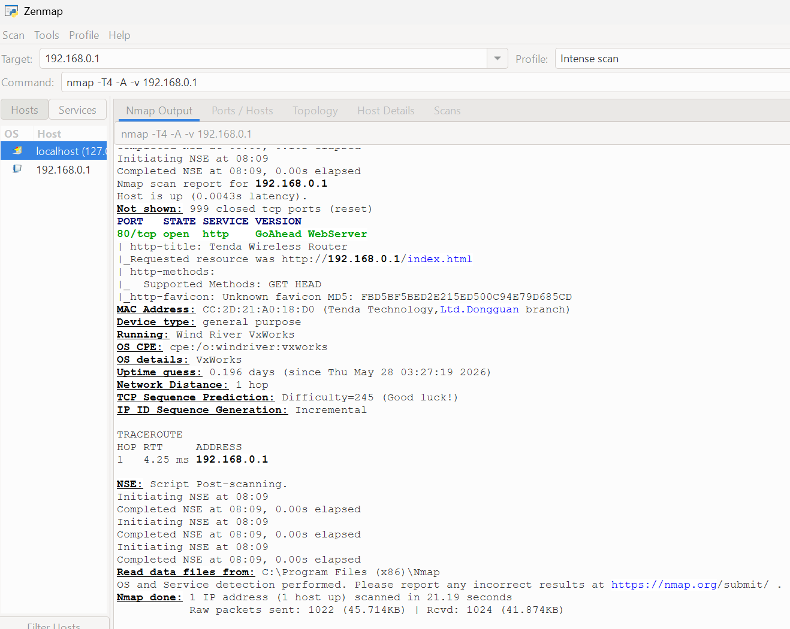Fig 1: Nmap scan of router (192.168.0.1) showing open HTTP service and device detail
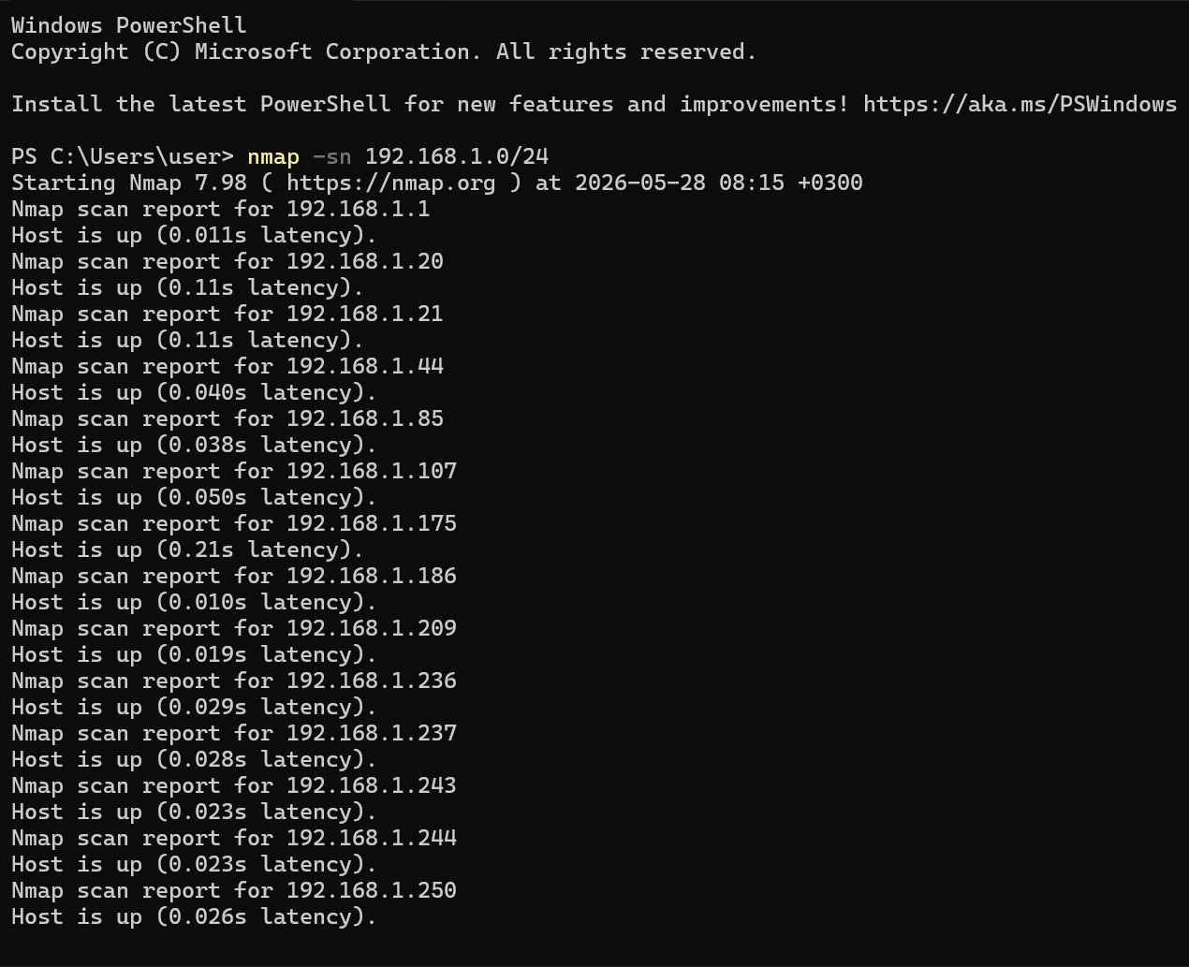Fig 2: Nmap host discovery scan showing active devices on the local network (192.168.1.0/24)
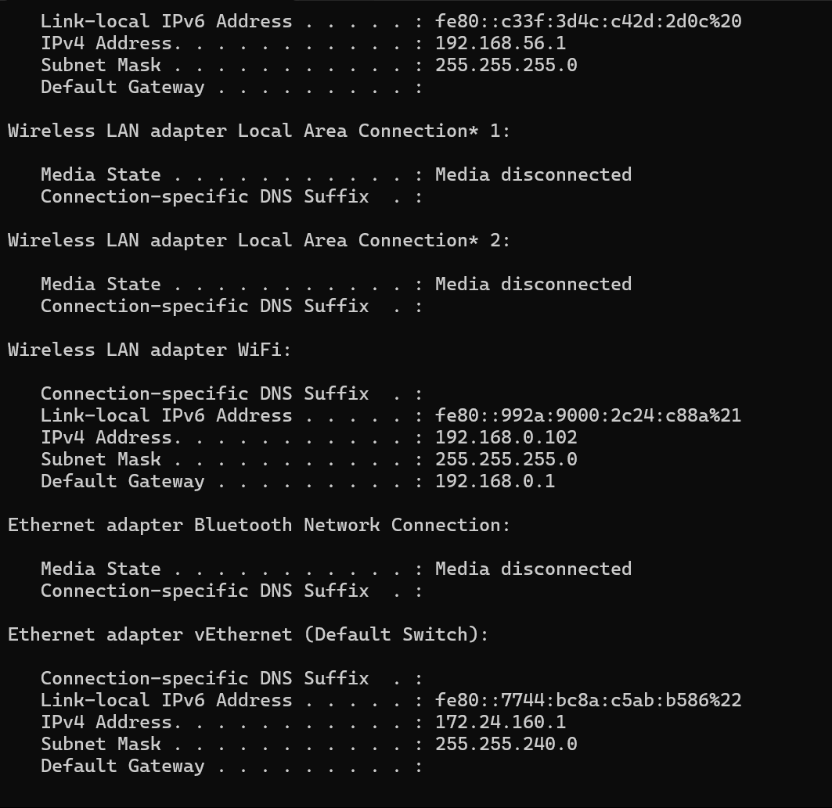Fig 3: Windows IP configuration showing local network details and active network interfaces
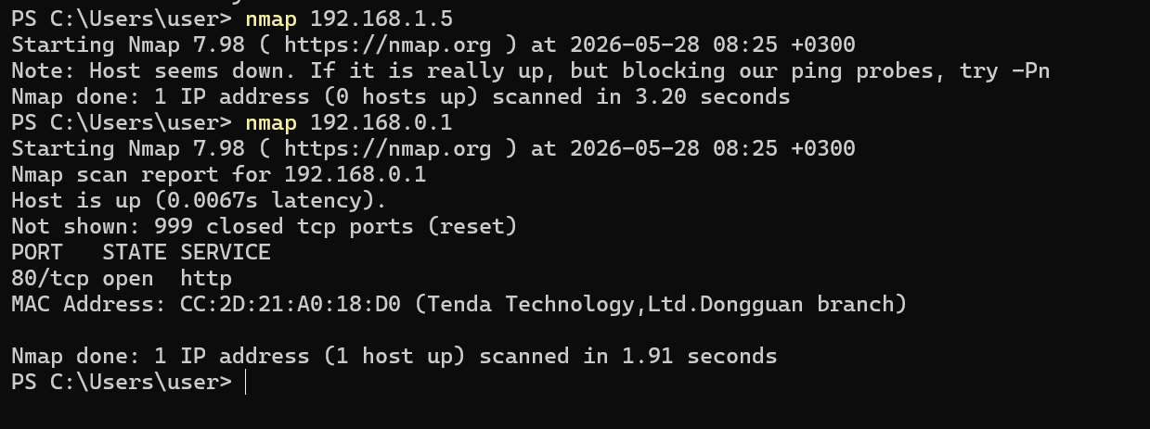Fig 4: Nmap host discovery scan executed in Windows PowerShell showing active devices within the local subnet and initial network reconnaissance results
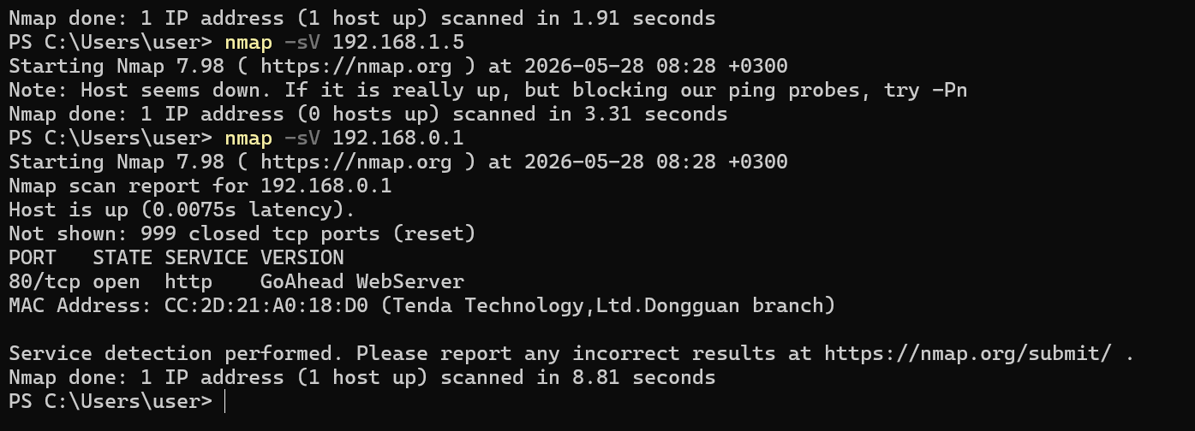Fig 5: Nmap service version detection scan in Windows PowerShell identifying the specific web server application running on port 80 of the active target.
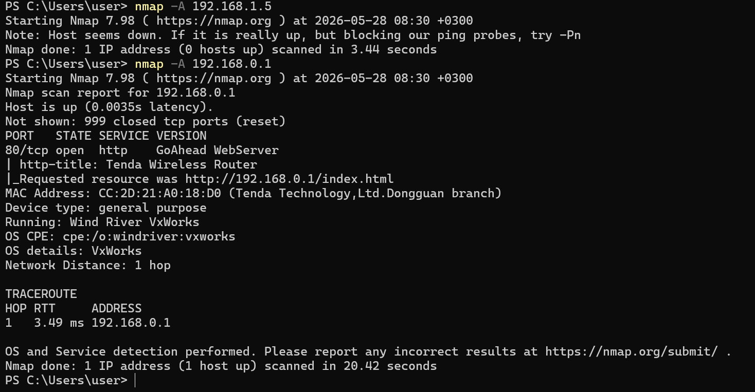Fig 6: Nmap aggressive scan (-A) output showing operating system detection and HTTP script results for the target host.
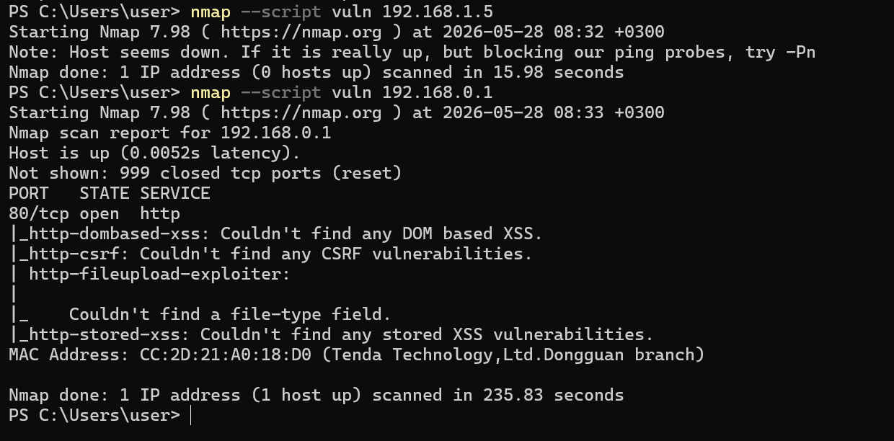Fig 7: Nmap vulnerability scan (--script vuln) output displaying automated security assessment results for the open HTTP service on the target host.

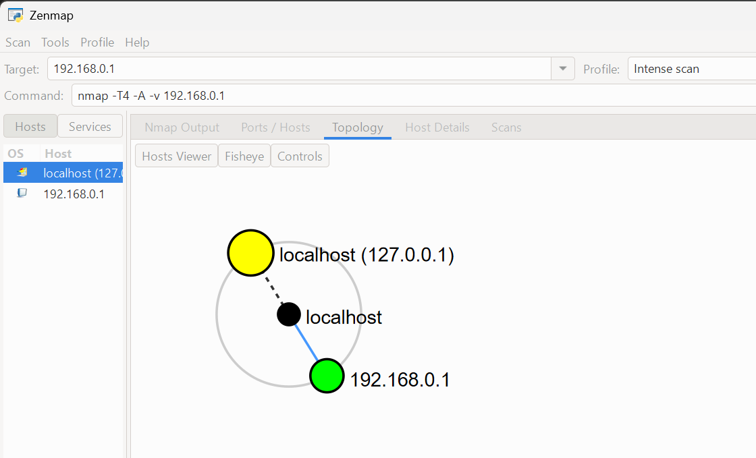Fig 8: Zenmap graphical user interface displaying the network topology and node relationship between the local host and the target IP address.
SAMPLE TASK 1
Company Background
Kenya Revenue Authorities
Home - KRA
Tools used
- WHOIS
- NSLOOKUP
- Wappalyzer
- crt.sh
- Have I Been Pwned
- Maltego

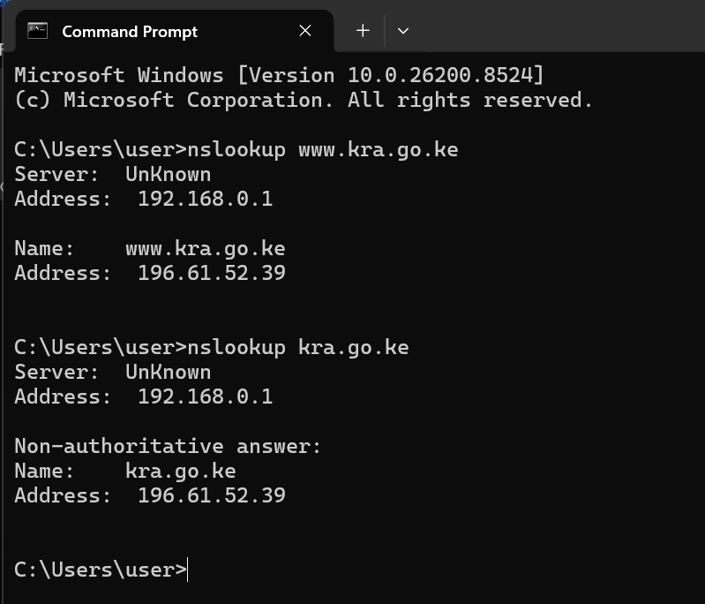
Figure 8:Nslookup results showing DNS resolution and IP address information for the KRA domain (kra.go.ke).
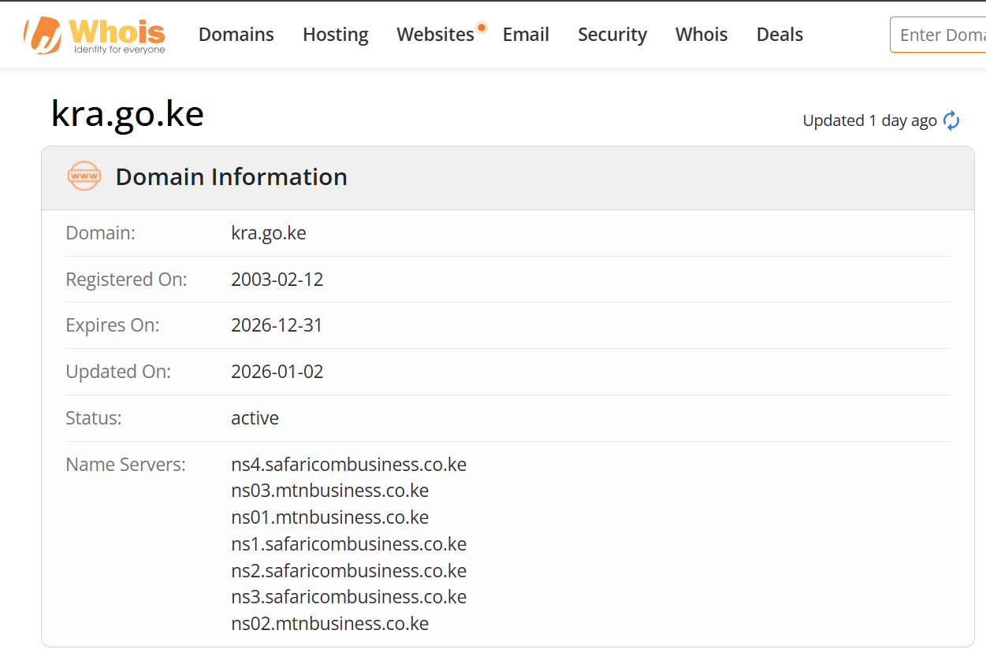
Figure 9: Domain Information
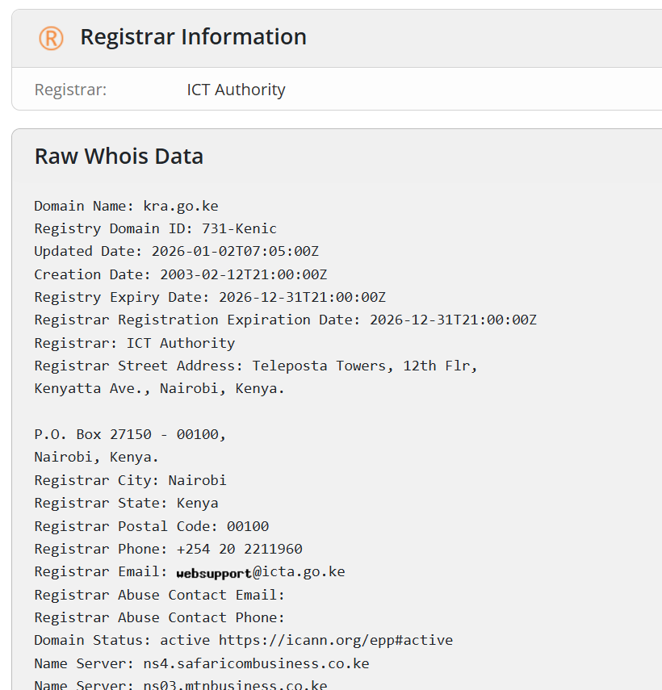
Figure 10: Registrar Information
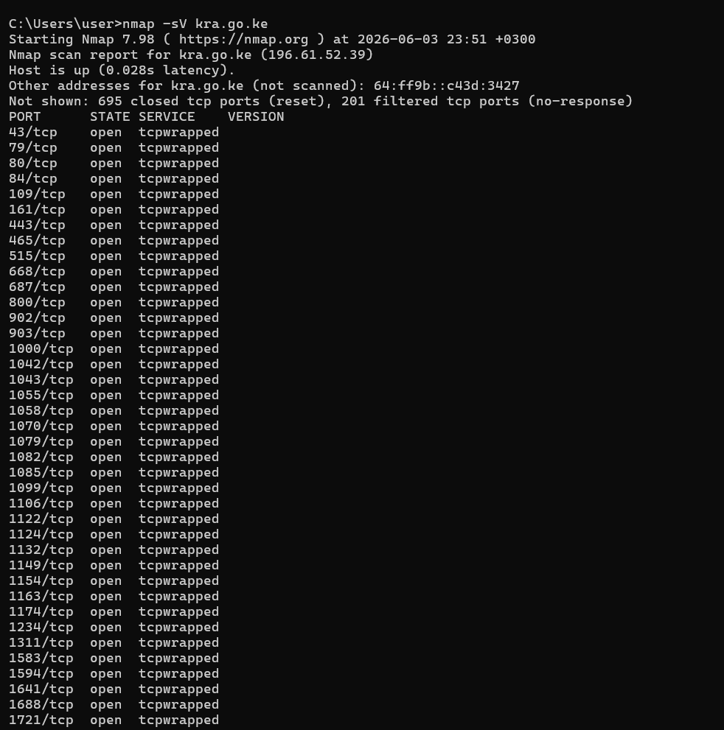
Figure 11: Open ports scan and services
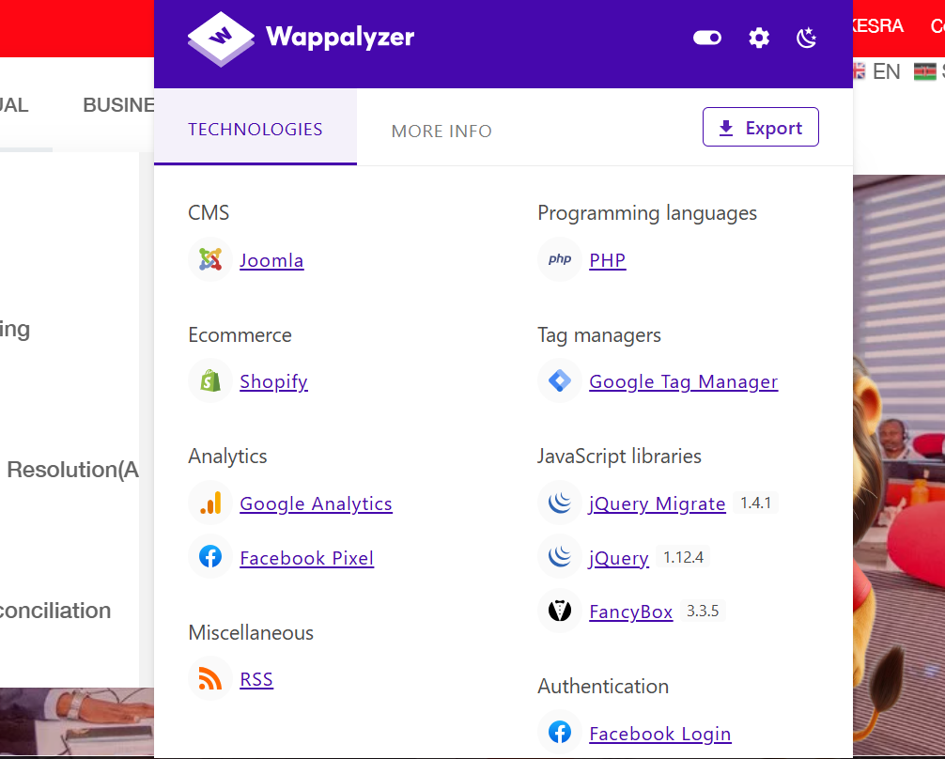
Figure12: Wappalyzer showing technologies used
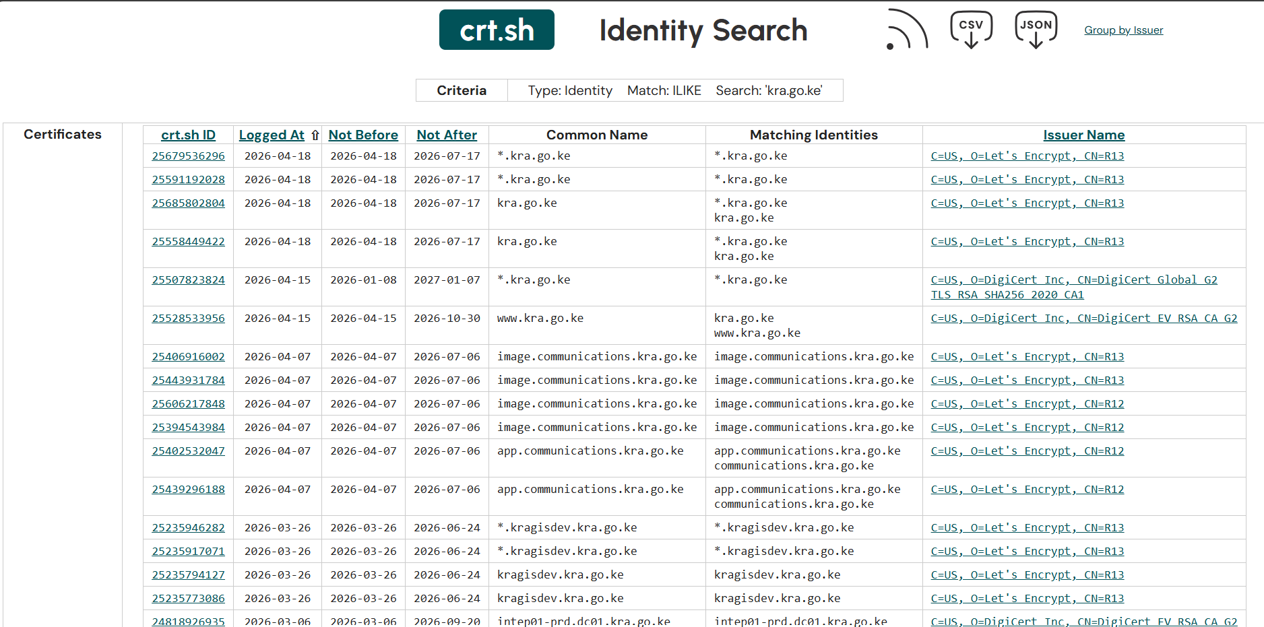
Figure 13:Results from crt.sh showing Certificate Transparency records associated with the KRA domain, revealing multiple subdomains and services linked to the organization.
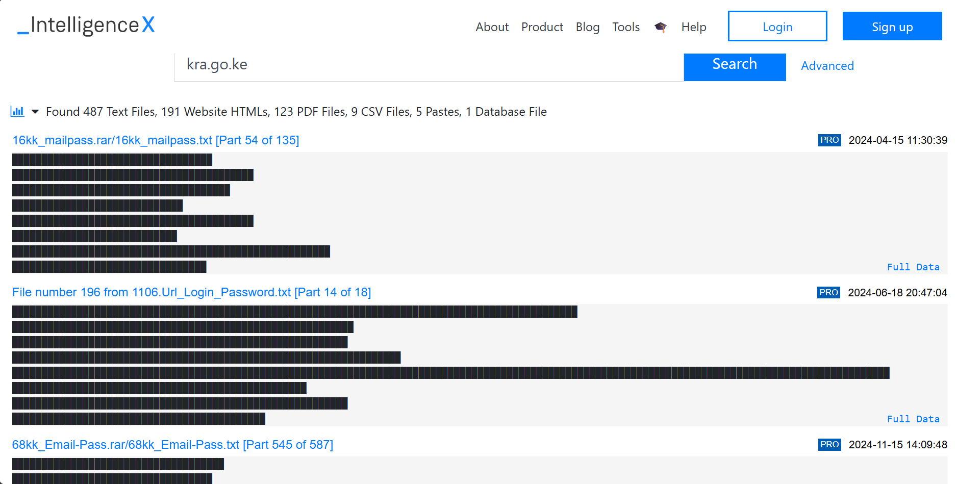
Figure 14: Intelligence X search results for kra.go.ke revealing 487 text files, 191 HTML files, 123 PDF files, 9 CSV files, 5 pastes and 1 database file containing leaked email and password combinations associated with the domain.
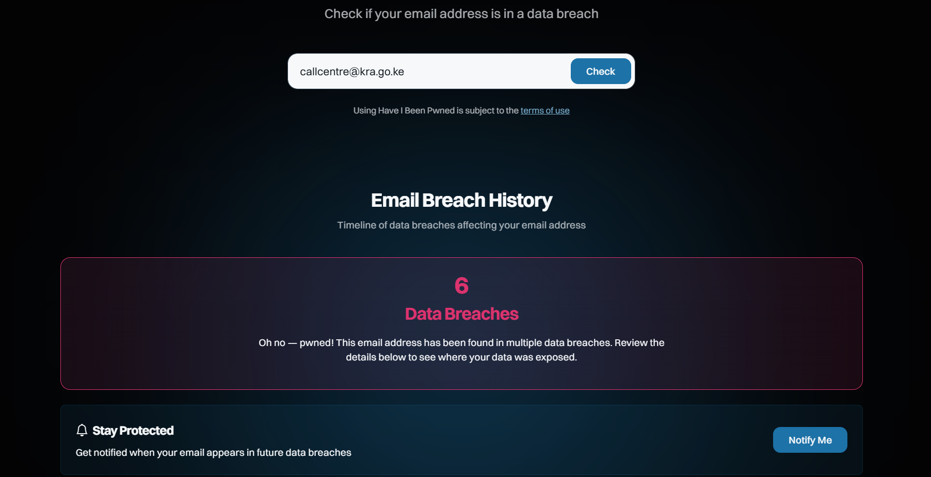
Figure 14: Have I Been Pwned results for callcentre@kra.go.ke confirming the email address has appeared in 6 data breaches, indicating significant credential exposure risk.
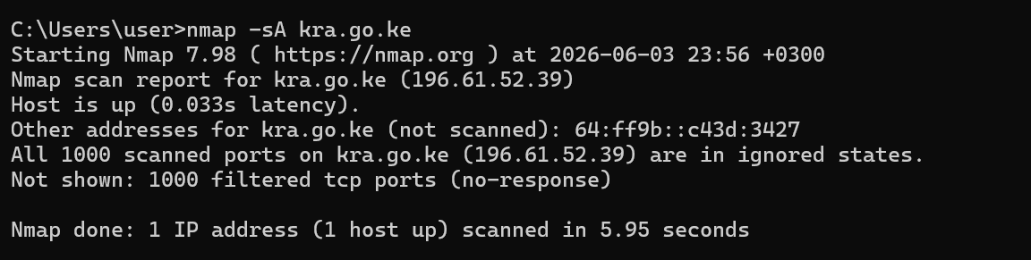
Figure 15: Nmap ACK scan on kra.go.ke (196.61.52.39) showing all 1000 scanned ports in a filtered state with no response, confirming the presence of a firewall protecting the organization's infrastructure.

Task 2: Scan Specific Machine
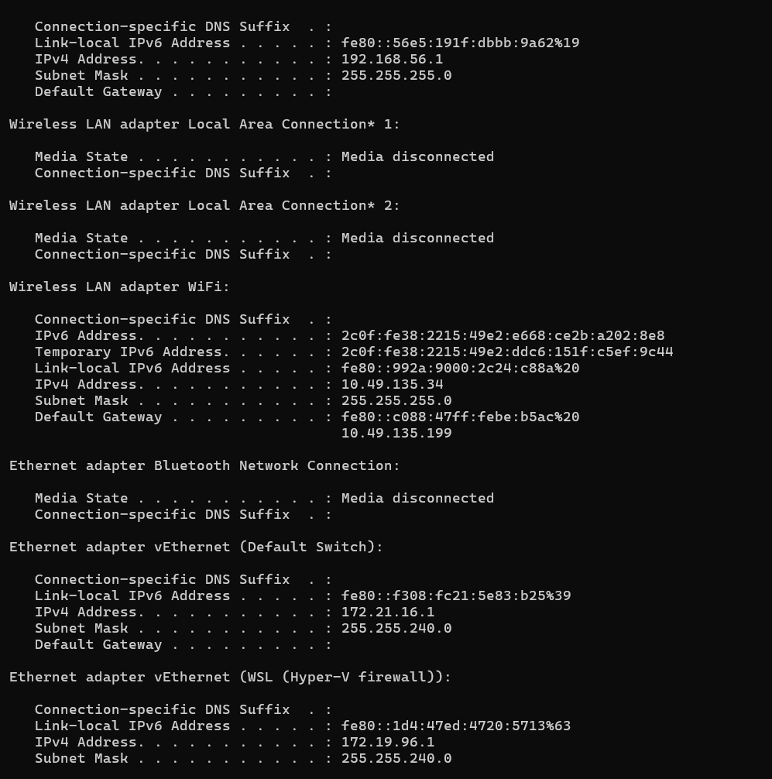
Figure16:Ipconfig output displaying network adapter configurations and IP addresses of the host machine.
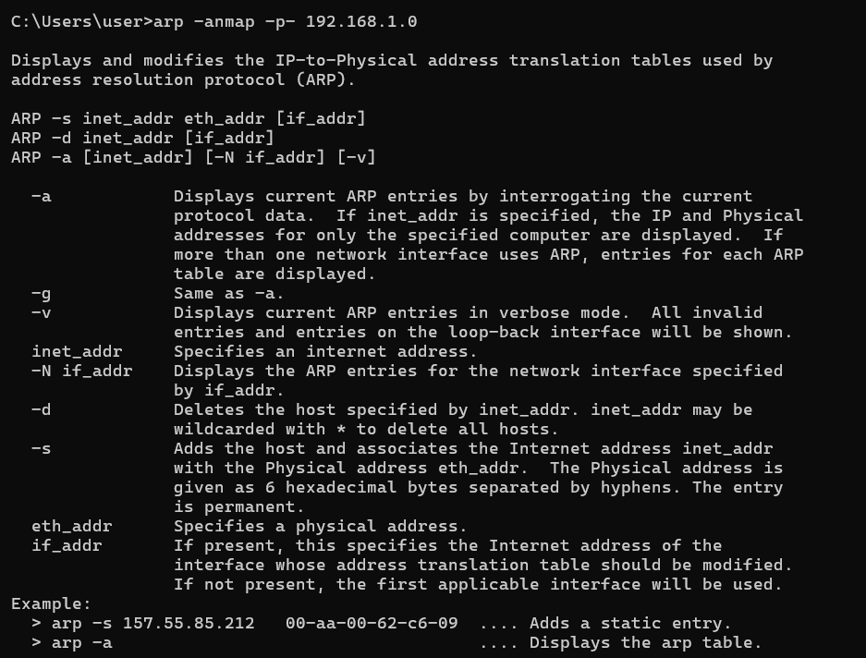
Figure17: Scan Ports, ARP command help page displayed due to incorrect syntax entry.
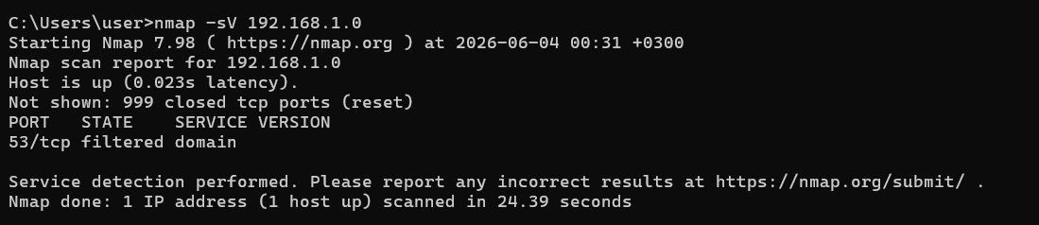
Figure18: Nmap service version scan on 192.168.1.0 revealing one open port — port 53 (DNS) in a filtered state, with 999 closed TCP ports detected.

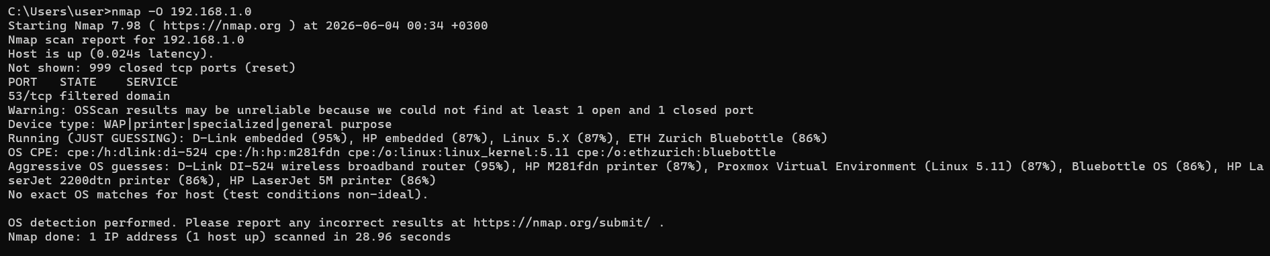
Figure19: Nmap OS detection scan on 192.168.1.0 identifying the device type as a WAP/printer with possible operating systems including D-Link embedded, HP embedded, and Linux 5.X.

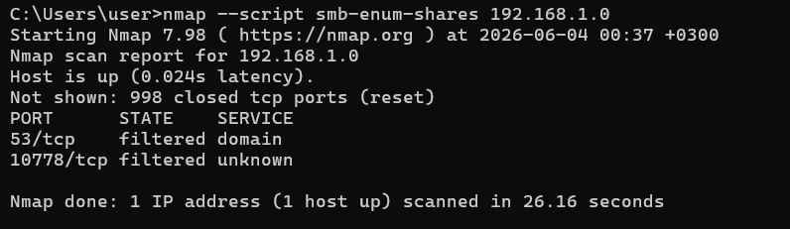
Figure20: Nmap SMB enumeration scan on 192.168.1.0 showing two filtered ports (53/TCP - DNS and 10778/TCP - unknown) with no shared folders accessible, indicating restricted netwo

